**ENVIRONMENTAL SETUP**

|  |  |
| --- | --- |
| **Date** | **10 NOV 2022** |
| **TEAM ID** | **PNT2022TMID13419** |
| **Project Name** | **CUSTOMER CARE REGISTRY** |

**FLASK SETUP:**

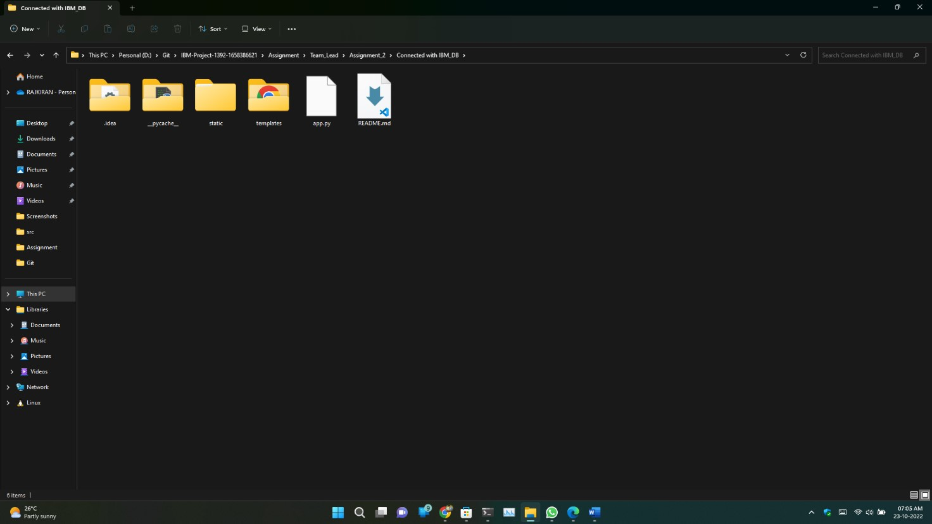

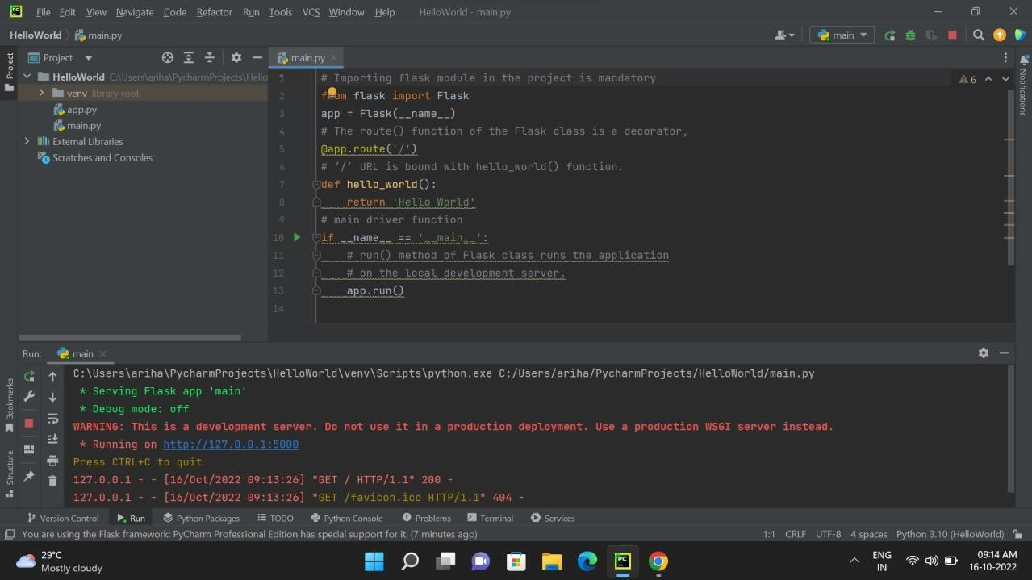

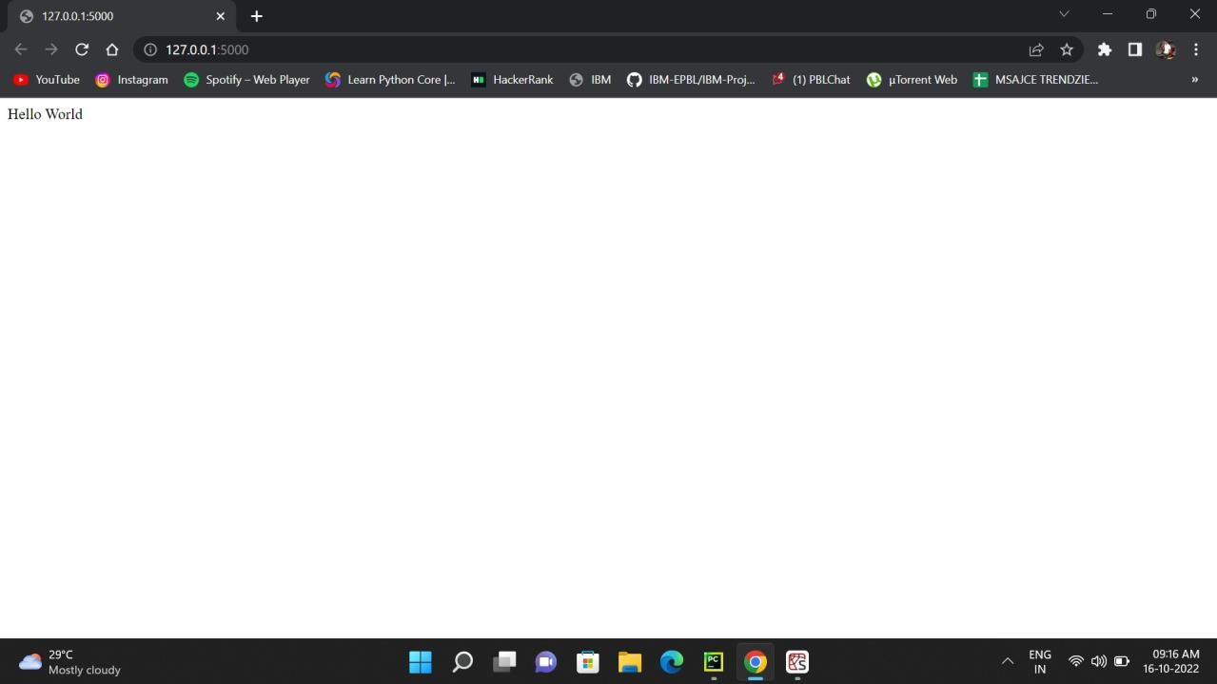

**DOCKER SETUP:**

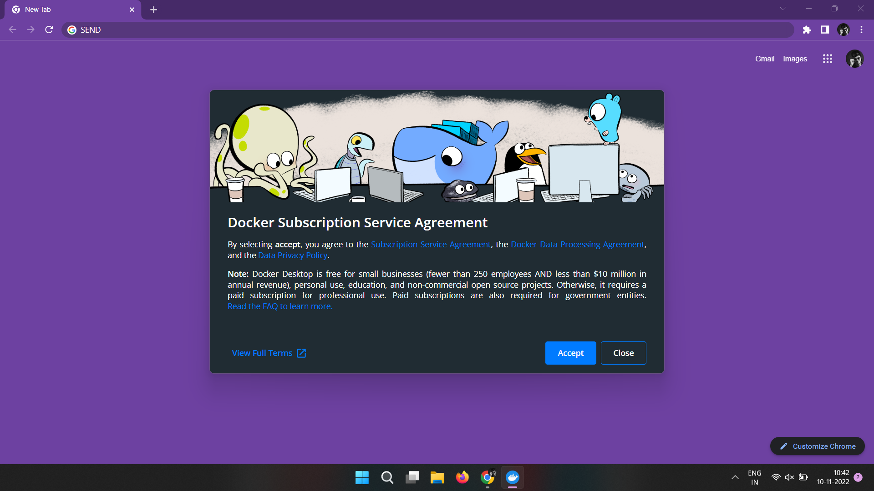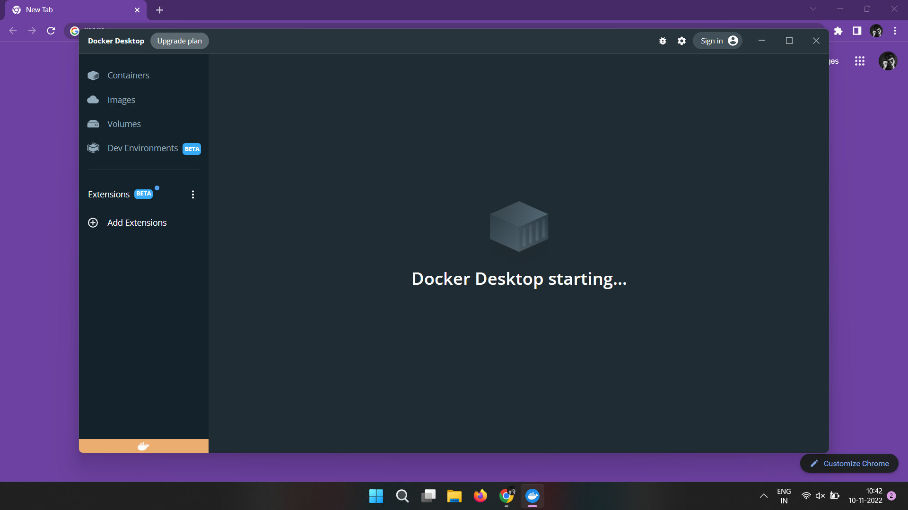

**COLUD ACCOUNT CREATION:**

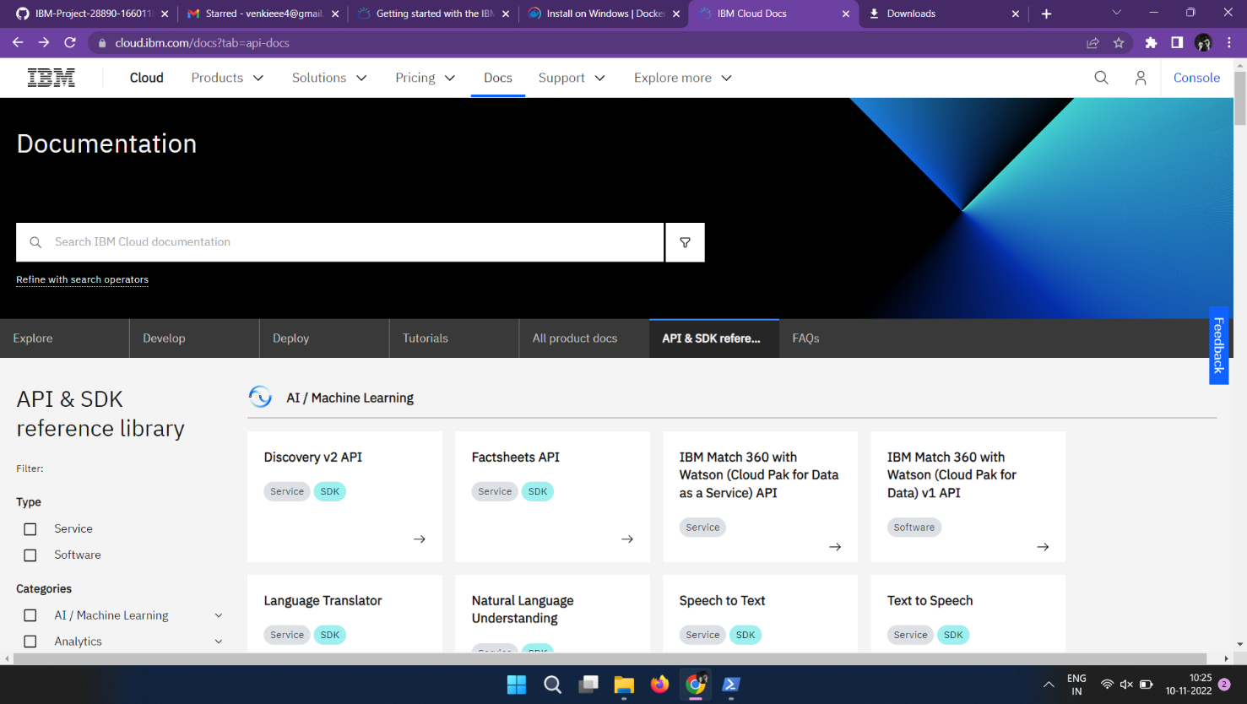

**SENDGRID ACCOUNT CREATION:**

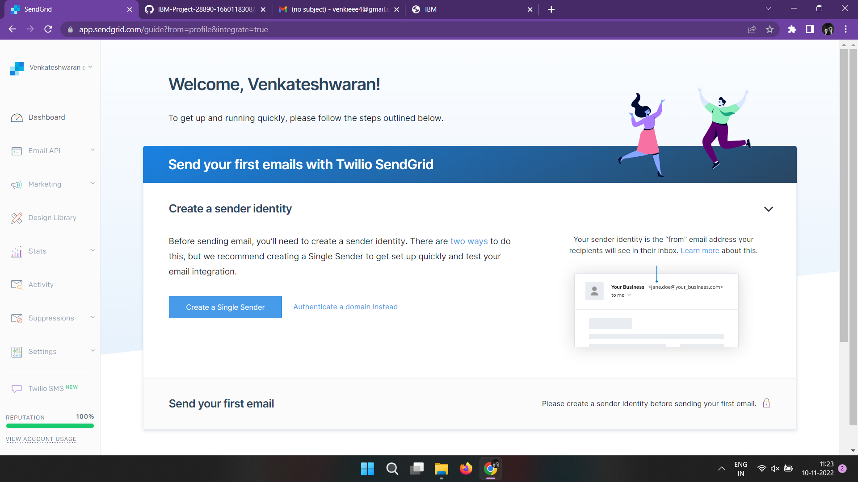

**IBM CLOUD CLI INSTALL :**

